The Passing of a Great Grandfather’s Legacy
This is food for thought for any who believe they leave behind their National Geographic Magazine Collection as a legacy for those to follow.
Many years ago, sometime after 1903 a Great Grandfather began his journey collecting the National Geographic Magazine (NGM). With the first published issue being October 1888, he was behind the power curve.
I had the pleasure of appraising this collection knowing it was the previous owner’s (heretofore – the Man’s) Great Grandfather that began it. He, the Great Grandfather, had to have begun collecting after 1903 as that was the last NGM published membership list, and his name was not on it. I also know it could not have been too long after that, as he was around early enough in the game to capture, in fine condition, the Volume I, No. 2 and No. 4 issues – the rarest two issues of the NGM publications. It was also about this time the National Geographic Society began to advertise for buy-back these two already scarce issues.
The Man’s Grandfather inherited the set and continued it. Sometime during the late 1950’s or early 1960’s either the Grandfather or the Man’s Father used a manual typewriter to assemble an inventory of what was on hand. At the time of this inventory, there were three missing issues from volumes 2 and 4, and three missing issues from the 1950’s. In 1967, hand written notes indicated the inventory list was complete.
In 1971, Edwin C. Buxbaum indicated only 215 to 225 complete sets were then known to exist. Approximately 100 of these sets were in private collections. I surmise this must have been one of those 100.
The Man asking for the appraisal inherited the collection sometime around 2012. He and his wife stated they tried many times to sell the collection, but no interest was ever shown. In the end, they donated it to the Kidney Foundation of Atlanta.
By the time I was asked to provide an appraisal (see appraisal: http://ngscollectors.ning.com/forum/topics/complete-collection-1888-2005-value ); the collection had been donated and subsequently dispersed to 11 Atlanta area thrift shops.
On the way to dispersal:
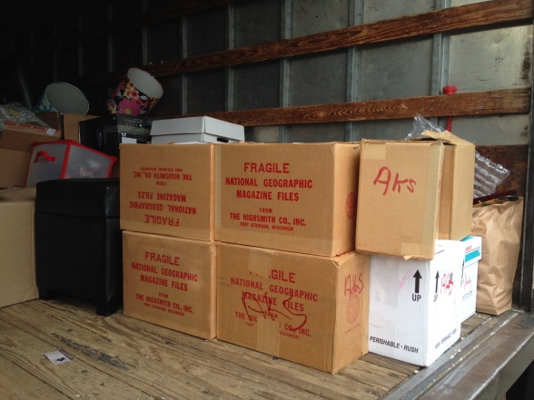
Attempting to follow-up, the Kidney Foundation refused to provide any additional information and would not give out telephone numbers to their thrift shops.
The book dealer that contacted me for the appraisal, on the Man’s behalf, chose to pound the streets in search of the most valuable portion of the collection spending hours travelling to the widely dispersed thrift shops to no avail.
Perhaps, one day, some of these issues may find their way on the market. For now, they and the Great Grandfather’s legacy are lost to the wind.

